Name: | ___________________________________________________ |  |  | Date: ___________
 | Year 9 Mathematics  Test 6, 2015  Topics – Scientific notation, congruency and similarity |  |  | 45  = %
Total Time: |  | 40 minutes
Weighting: |  | ______% of the year.
Equipment Allowed: |  | ½ page of notes (A4 one side), calculator

CALCULATOR ALLOWED

Part A – Multiple Choice [5 marks: 1 each]

For the following multiple-choice questions, circle the correct answer.

1. | Which of the congruence tests could be used to show that  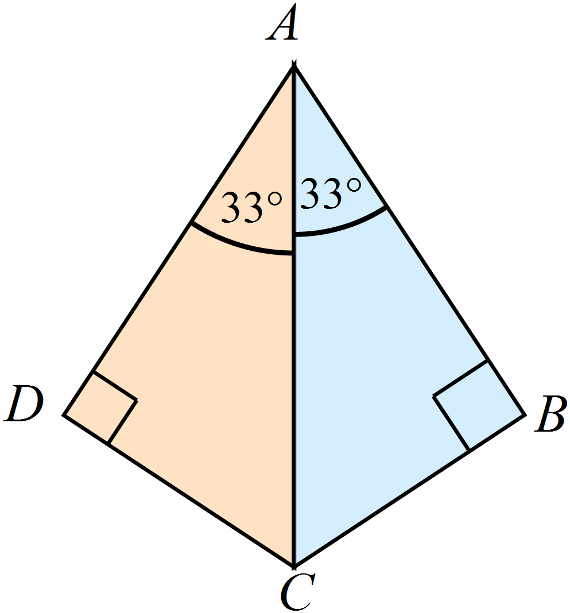
 |  | AAS |  | RHS |  | SAS |  | SSS

2. | Which of the congruence tests could be used to show that .  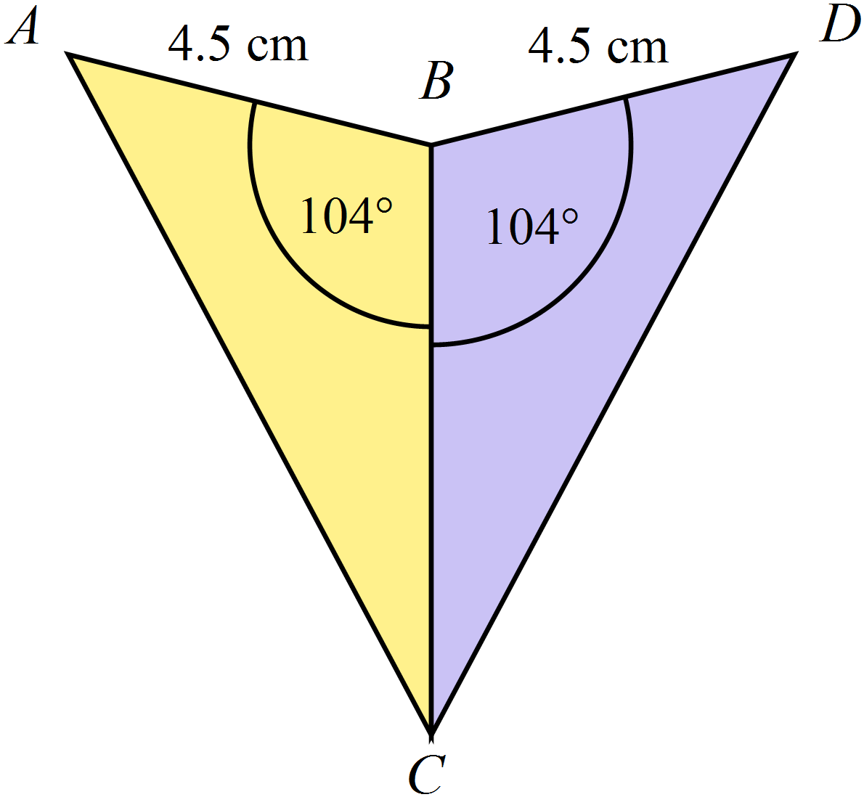
 |  | AAS |  | RHS |  | SAS |  | SSS

3. | An equilateral triangle of side length 15 cm is reduced to become a triangle of side length 5 cm. The scale factor used is:
 |  |  |  | 5 |  |  |  | 115

4. | A square with sides 6 cm is enlarged with scale factor of 4.  What is the area of the new square?
 |  | 24 cm |  | 36 cm² |  | 96 cm |  | 576 cm²

5. | Robin takes a photograph, which measures 8 cm by 10 cm, to the printers to make a poster.  The poster is 8 times the size of the photograph.  What is the measurement of the poster on its shorter side?
 |  | 64 cm |  | 72 cm |  | 80 cm |  | 160 cm

Part B – Short-answer questions

6. | [3 marks: 1, 1, 1]
Use words from the list below to complete the following sentences.

scale factor similar congruent figure side
a) | Two triangles are _____________________ if they are the same shape and the same size.
b) | Triangles that are the same shape but not the same size are _____________________.
c) | The ____________________ is the ratio between the sides of two similar figures.

7. | [5 marks: 1, 1, 1, 1, 1]
a) | Write the following numbers in scientific notation:
 | i) | 92 017 000 | ii) | 0.000 056 2
b) | Write the value of the following numbers written in scientific notation
 | i) | 3.2 × 10⁴ | ii) | 7.23 × 10⁻³
c) | Evaluate 4.56 × 10⁻³ ÷ 5.89 × 10⁻⁸. Express your answer in standard form.

8. | [3 marks: 1, 1, 1]
a) | How many significant figures does the number 23.40 have?
b) | How many significant figures does the number 0.0042 have?
c) | Round 13.9998 to four significant figures.

9. | [2 marks]
Give reasons why the following pair of triangles are congruent.
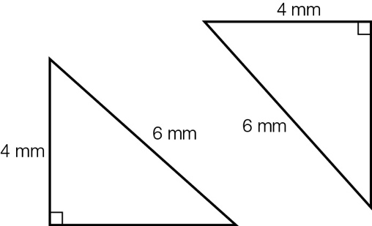

The hypotenuse in each triangle = _______ mm

Each triangle has another side equal to ______ mm

Each triangle has a ___________ angle

The triangles are congruent using the _________ test.

10. | [4 marks]
Show that the pair of triangles are similar.
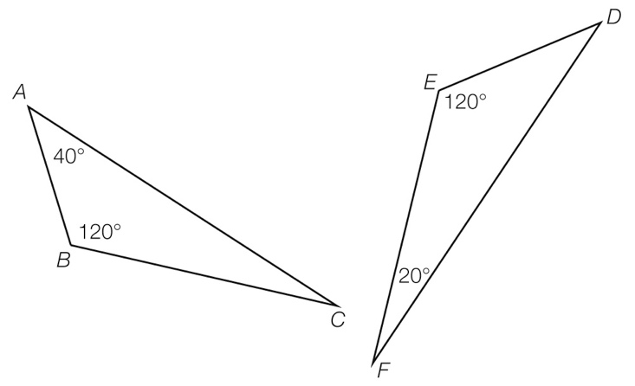
Statement | Reason

11. | [4 marks]
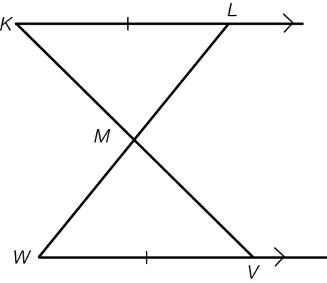
Prove $∆KLM \sim ∆MVW$

Statement | Reason

12. | [5 marks]
Christy’s dad bounces a ball from his head height and Christy catches it at her head height, as the following diagram shows. Prove the following triangles are similar and find how tall Christy is (x).
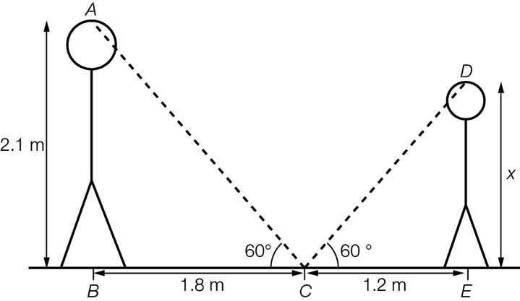

Statement | Reason

13. | [2 marks]
Use the properties of similar triangles to find the distance across the river, correct to one decimal place.

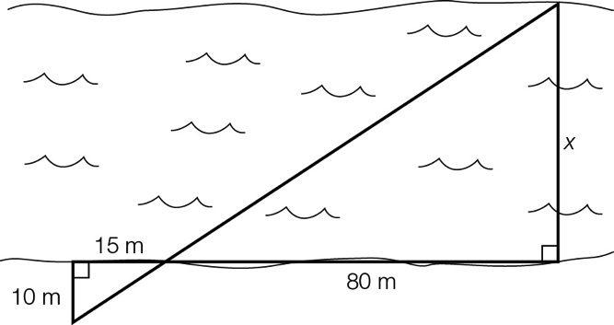

14. | [4 marks]
Prove that ∠ABC = ∠DEC.
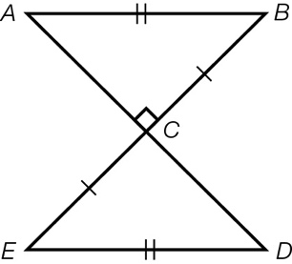
Statement | Reason

15. | [2 marks]
 | The area of a triangle is 45 cm². What is the area of this triangle after the dimensions of the triangle have been reduced by a scale factor of ?

16. | [4 marks]
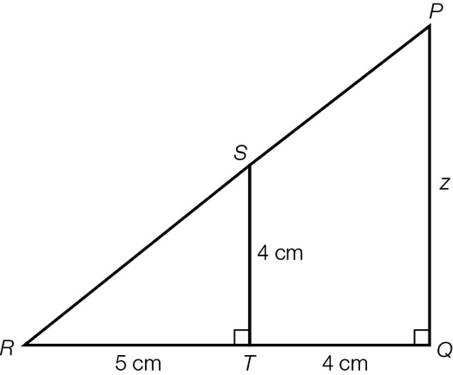
Show that the two triangles are similar and then find the value of z.

Statement | Reason

~ END OF TEST ~

